Class-Specific Mahalanobis Prototypes for Few-Shot Class-Incremental Microplastic Identification Using FTIR Spectroscopy
Jiating Li ª, Xinyu Yan ^{b}, ^{c}, ^{d}, ^{e}, ^{e}, ^{f}
ª Technological University of the Shannon: Midlands, Ireland. Luoyang Institute of Science and Technology, China, xinyuyan1989@gmail.com. (Corresponding Author)
^{b} Materials Research Institute, Technological University of the Shannon: Midlands, Ireland. Email: zhi.cao@tus.ie.
^{c} Materials Research Institute, Technological University of the Shannon: Midlands, Ireland. Email: alanj.murphy@tus.ie.
^{f} Software Research Institute, Technological University of the Shannon: Midlands, Ireland. Email: , xinyuyan1989@gmail.com (Corresponding Author)
Abstract
Microplastic (MP) pollution is a widespread environmental concern, creating a need for accurate and efficient polymer identification. Attenuated total reflection Fourier transform infrared (ATR-FTIR) spectroscopy combined with machine learning has been widely used for this purpose, but model reusability is often limited by the introduction of new polymer classes and by spectral-resolution differences across datasets. This study proposes a few-shot class-incremental learning framework based on Prototypical Networks with class-specific shrinkage Mahalanobis distance. A multiscale convolutional neural network is trained using episodic learning, while covariance shrinkage improves prototype-based classification with limited labelled samples. Spectral interpolation is employed to harmonise FTIR data across different resolutions. Experiments on six polymer categories demonstrate classification accuracies of 96.53% and 96.03% in two within-resolution settings using 5–10 labelled samples per new class. With target-resolution reference spectra for existing classes, accuracies of 94.40% and 95.92% are achieved in bidirectional cross-resolution evaluation without retraining the encoder. Although PCA-based representations remain competitive, the results demonstrate the potential of class-specific Mahalanobis prototypes for flexible and reusable FTIR-based microplastic identification.
List of Abbreviations
Abbreviation | Meaning
MP | Microplastic
ATR | Attenuated Total Reflection
FTIR | Fourier transform infrared spectroscopy
ML | Machine Learning
SVM | Support Vector Machines
KNN | K-Nearest Neighbours
MLP | Multilayer Perceptron
ANN | Artificial Neural Network
PCA | Principal Component Analysis
LDA | Linear Discriminant Analysis
EPR | Ethylene propylene rubber
PE | Polyethylene
LDPE | Low density polyethylene
HDPE | High density polyethylene
PP | Polypropylene
PS | Polystyrene
PA | Polyamide
ESMA | Extended Multiplicative Signal Augmentation
Keywords
Microplastic Identification, Machine Learning, Data Augmentation, FTIR, Deep Learning, Data Pre-processing
- Introduction
Microplastics (MPs) pose a significant environmental threat to oceans worldwide. (Neto et al., 2020). MPs are increasingly detected in shallow seawater and within the digestive systems of various marine organisms (Bostan et al., 2023). This indicates that marine creatures are ingesting increasing amounts of polymer particles, it can cause great harm or even life-threatening to their organs. Simultaneously, these marine species with toxic chemicals will impact human health via the food chain (Mecozzi et al., 2016). These marine MP pollutants are mainly derived from the territorial plastic litter, commercial fishing activities and diverse seaside tourism (Cole et al., 2011). Hence, monitoring and detecting microplastics (MPs) is a crucial and effective approach to locating sources of contamination based on the types of MPs present. This, in turn, provides insights and solutions for reducing the production of these toxic plastic products and their entry into the ocean.
Attenuated Total Reflection Fourier Transform Infrared Spectroscopy (ATR-FTIR) has been the most widely used method to identify MPs (Michel et al., 2020) (Renner et al., 2018). For systematic and standard analysis of MP FTIR data, the workflow of pre-processing dataset has been summarised (Renner et al., 2019).
To develop automatic analytical method, Machine learning (ML) based identification approaches are applied on FTIR spectrum for clustering and classification MPs (Primpke et al., 2018) (Back et al., 2022) (Hufnagl et al., 2019). To obtain more accuracy and better performance results, pervious works have utilised various ML methods to explore the appropriate approach suitable for MP identification e.g., Support Vector Machines (SVM) (Back et al., 2022), Random Forests (Hufnagl et al., 2019),K-Nearest Neighbours (KNN) (Kedzierski et al., 2019), Linear Discriminant Analysis (LDA) (Michel et al., 2020). An ensemble learning method based on neural network has been proposed to exploit the advantages of different ML methods (Yan et al., 2022). However, if none of the machine learning methods within an ensemble learning model can obtain high accuracy (above 90%) in identifying a specific type of microplastic, the ensemble model will also fail to identify that MP. This is because most widely used open-source datasets, including those from Kedzierski’s research (970 spectra) (Kedzierski et al., 2019), Jung’s study (798 spectra) (Jung et al., 2018a), and Hannah’s work (179 spectra) (De Frond et al., 2021), often lack sufficient samples, suffer from class imbalance, or are contaminated during sampling, making them inadequate for effective model training. Detailed descriptions of these three datasets can also be found in previous work (Yan et al., 2023).
To solve this problem, the limited data augmentation methods of FTIR or 1 dimensional data have been developed. The current works include: 1) Extended Multiplicative Signal Augmentation (EMSA) (Blazhko et al., 2021), which is based on Extended Multiplicative Signal Correction (ESMC) (Kohler et al., 2005). This method adopts the least square method to calculate the average trend of all spectrums of one type of MP and then randomly scales the distances between each MP spectrum and the average trend to augment the dataset; 2) Baseline based method (Bjerrum et al., 2017), which adds random baselines to the original spectrums for generating spectral samples with slope and noise to enhance the dataset; 3) Generative Adversarial Network (GAN) based method (Brandt et al., 2021), which uses GAN to add noise and generate the new spectral samples based on the original dataset. 4) Fingerprint Region based Data Augmentation (FRDA) method to split the spectral data into segments for each MP type, and then creating new spectral sample by assembling the regions from different data samples of the same MP type (Yan et al., 2023). Data augmentation methods provide an effective way to address dataset and improve the performance of existing machine learning–based methods.
Another way to solve the data imbalance is collect enough data samples, recent research has collected a sufficient amount of data to provide a balanced number of samples(Villegas-Camacho et al., 2024). They present a dataset called FTIR-Plastics, which includes FTIR data for 6 most common industrial plastics. The dataset is divided into two subsets with different spectral resolutions. Each subset contains 3,000 spectra, resulting in a total of 6,000 spectra. The data quality of both subsets is high, enabling reliable validation of the proposed machine learning based methods. However, to allow reuse of the trained model across datasets, harmonisation is required to address differences in spectral resolution. In addition, acquiring a large number of high quality spectra from ocean environments is particularly challenging.
Based on these discussions, current machine learning based FTIR identification methods face two major challenges. The first challenge is that datasets often contain spectra with different spectral resolutions, which limits the reusability of trained models. The second challenge is how to rapidly construct new microplastic categories using limited data, without retraining or degrading existing models.
This motivates us to design a more effective preprocessing method for microplastic FTIR datasets, as well as a more adaptable machine learning or deep learning approach for model reuse and transfer. The key concept is to replace the traditional smoothing process in the machine learning–based microplastic identification workflow with the proposed method, and to apply an improved prototypical neural network to enable few-shot learning. This allows new sample prototypes to be rapidly added to the category set without retraining the model. The contributions of this paper can be summarised as follows:
- This work proposes an updated workflow for processing and augmenting FTIR data to improve model robustness and reusability.
- This work proposes a few-shot learning method for FTIR data, termed the Adaptive Mahalanobis Distance-Based Feature Extraction Prototypical Neural Network.
- Materials and methods
  - ATR-FTIR datasets
FTIR is a common technique for analysing the chemical structure by producing infrared spectrum of absorption. ATR-FTIR applies the ATR on FTIR to facilitate the measurement procedure (Halstead et al., 2018a) (Smith et al., 2019). The following are some of the benefits that this technology provides: 1) There are no additional requirements regarding the size, water content and shape of the sample to be tested. 2) Sample preparation is simple and non-destructive. 3) The sensitive detector is precise, the measurement zone is tiny, and detection precision can range from a few microns to several microns. 4) An ATR instrument may be installed on a regular FTIR to provide a low-cost option (Halstead et al., 2018b).
The dataset previously used is sample unbalance, and damaged, however, in the real scenario the the sample collected should be well prepared a
This work adopts 5 FTIR MP datasets (Kedzierski et al., 2019) (Jung et al., 2018b) (De Frond et al., 2021) for analysis. The first dataset is from Kedzierski’s research work containing 970 spectra (Kedzierski et al., 2019). The second dataset is from Jung’s research work containing 798 spectra (Jung et al., 2018b). The third dataset is from Hannah’s work containing 179 spectra (De Frond et al., 2021). Amongst the existing MP datasets, these three datasets encompass a board range of MP categories and a relevantly large quantity of data samples. In addition, they keep the entire wavelength spectrum, ranging from 4000 cm⁻¹ to 400 cm⁻¹. The datasets of Kedzierski and Jung are collected from ocean. The dataset of Hannah is collected from everyday plastics including 14 types of plastics. The details of these datasets are shown in Figure A.1 (Note that A.x denotes Additional figures or tables presented in Appendix A). This work has shrunk the Kedzierski, Jung and Hannah dataset to 11, 4, and 14 types respectively by deleting MP types with a sample size less than 5.
  - Cubic Spline Interpolation for Data preprocessing
The different datasets has different resolutions. Hence how to harmonised the data is the key to reuse the ML model.
In previous work, the first step in the workflow for machine learning (ML)-based methods using FTIR data is typically smoothing. However, if the data quality is high, this step may not be necessary. Furthermore, because the resolution of FTIR datasets often varies, interpolation methods can be a more effective alternative. They help reduce noise and standardize the data dimensions, facilitating model reuse across different datasets.
Cubic spline interpolation (McKinley and Levine, 1998) is a mathematical method commonly used to construct new points within the boundaries of a set of known points.
Given one set of data points (x₀,y₀), (x₁,y₁), …, (x_{n}, y_{n}), this method aim to find a set of piecewise cubic polynomials S_{i} (x) for interpolation, where each S_{i} (x) is a cubic polynomial function over the interval [x_{i}, x_{i+1}]
$S_{i}\left(x\right)=a_{i}+b_{i}\left(x-x_{i}\right)+c_{i}{\left(x-x_{i}\right)}^{2}+d_{i}{\left(x-x_{i}\right)}^{3}$ (1)
Here, a_{i}, b_{i}, c_{i}, d_{i} are the coefficients to be determined.
To ensure the curve is smooth and continuous at each node, the following conditions are usually required:
- Interpolation Condition: The curve’s value at each data point matches the data point.
$S_{i}\left(x_{i}\right)=y_{i,} S_{i}\left(x_{i+1}\right)=y_{i+1}$ (2)
- First Derivative Continuity: The first derivative is continuous at each internal node.
${S^{'}}_{i}\left(x_{i+1}\right)={S^{'}}_{i+1}\left(x_{i+1}\right)$ (3)
- Second Derivative Continuity: The second derivative is continuous at each internal node.
${S^{''}}_{i}\left(x_{i+1}\right)={S^{''}}_{i+1}\left(x_{i+1}\right)$ (4)
- Boundary Condition (Natural Boundary Condition): Typically, we set the second derivative at the endpoints to zero, known as the natural boundary condition.
${S^{''}}_{0}\left(x_{0}\right)=0, {S^{''}}_{n-1}\left(x_{n}\right)=0$ (5)
These conditions generate a set of equations, which can be solved using linear algebra to determine the coefficients a_{i}, b_{i}, c_{i}, d_{i} for each interval.
Figure 1 illustrates the FTIR spectral data of PET, where the cubic spline interpolated spectrum closely overlaps with the original measurements. This demonstrates that the spectral data can be accurately reconstructed at different resolutions while preserving the original spectral characteristics.
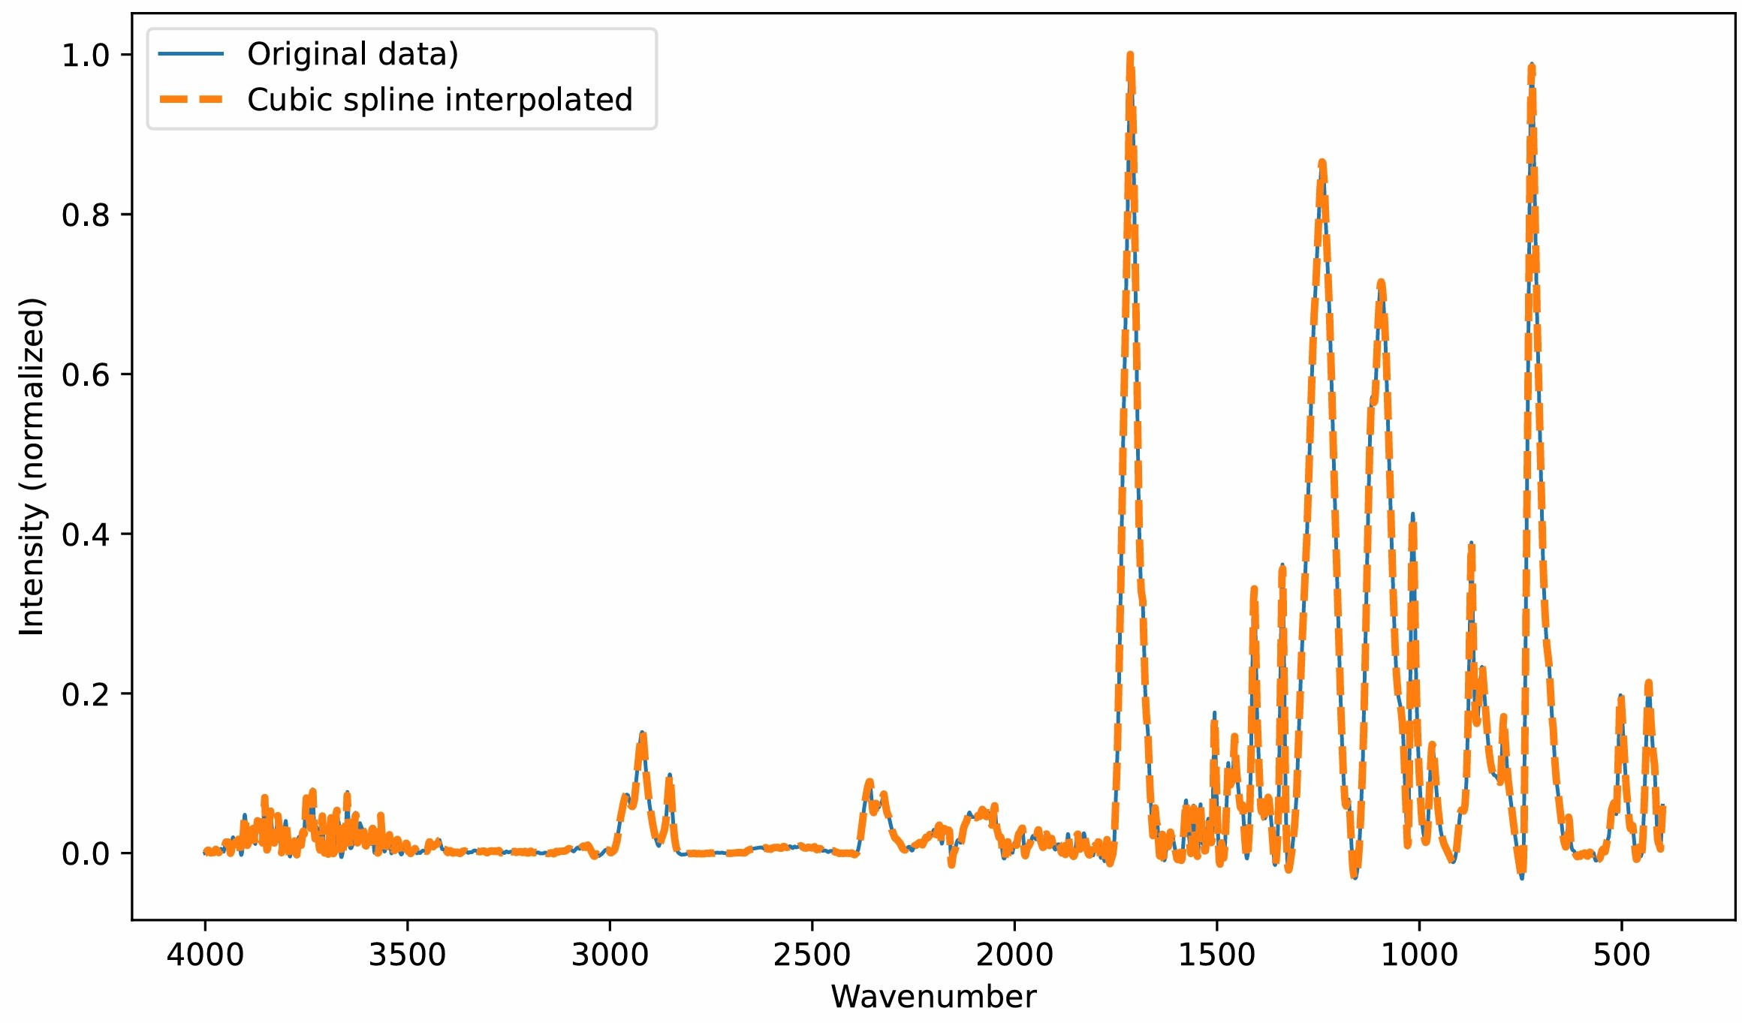
Figure 1 Comparison of original and cubic spline interpolated FTIR spectra of PET
  - Extended Multiplicative Signal Augmentation (ESMA)
ESMA is based on ESMC that is one spectral pre-processing approach for correcting the deviation produced by instrument or operation (Kohler et al., 2005). ESMC assumes that a measured spectrum is consisted of reference spectrum and baseline shift (that are generated from variations in light source between the background and samples during the measuring), multiplicative effect (that are derived from thickness of samples), and other noise generated from measurement. ESMC fits the parameters of these variables (reference spectrum, baseline shift and other noises) through the form of polynomial fitting. The spectral model of EMSC can be expressed as follows:
$A\left(\tilde{v}\right)=a+m\left(\tilde{v}\right)+b+d_{1}\tilde{v}+d_{2}{\tilde{v}}^{2}+⋯+d_{n}{\tilde{v}}^{n}$ (6)
Where $A\left(\tilde{v}\right)$ is the measured spectrum, $m\left(\tilde{v}\right)$ is the reference spectrum (in actual application scenarios, the reference spectrum commonly is the average value of the identical MP spectra), a, b, d₁, d₂, …, d_{n} are the parameters referring to the baseline shift, multiplicative effect and higher polynomial terms.
ESMA uses a Gaussian distribution to estimate the parameters of the spectrum data for each MP type calculated by ESMC model. Afterwards, it randomises the samples with the Gaussian distribution for each spectrum frequency to generate the full spectrum range for a specific MP.
  - Few Shot Learning methods for Classification
This section will introduce some commonly used few shot learning methods.
Prototypical neural networks (Snell et al., 2017).
For prototypical neural network there 2 common used metrics:
- Squared Euclidean Distance
- Mahalanobis distance

    - MAML
Prototypical neural networks.
Squared Euclidean Distance
Mahalanobis distance
Generation-based.
The data augmentation method is also a few shot learning method, but this work want combine them together.
    - Adaptive MahalaNobis distance based Prototypical neural networks
The Mahalanobis Distance is a statistical measure used to determine the distance of a point from a data distribution (De Maesschalck et al., 2000). Unlike Euclidean distance, Mahalanobis Distance takes into account the covariance matrix of the dataset, allowing it to reflect the distribution and directionality of the data. This distance is particularly suitable for high-dimensional data in classification and anomaly detection tasks.
Given a point x, the mean μ of the dataset, and the covariance matrix Σ, the Mahalanobis Distance is defined as:
$D_{M}\left(x\right)=\sqrt{{{\left(x-μ\right)}^{T}}^{ }\sum^{-1}{(\left(x-μ\right))}}$ (7)
The previous work has evaluated Support Vector Machines (SVM) (Back et al., 2022), Random Forests (Hufnagl et al., 2019),K-Nearest Neighbours (KNN) (Kedzierski et al., 2019), Linear Discriminant Analysis (LDA) (Michel et al., 2020), Multilayer Perceptron (MLP). algorithms for MP classification. The results show that SVM, KNN, and MLP have performed the best.
SVM is originally utilized in binary classification (Cortes and Vapnik, 1995). Then, it is extended to solve the multiclassification issues with limited samples. It is a set of approaches to map every point to a "high-dimensional space", afterwards, it finds a "hyperplane" in the high-dimensional space that can divide those points e.g., the hyperplane in a 2-dimensional plane is a straight line and so on.
The K-Nearest Neighbours (KNN) is an approach to calculate the distance between an unknown sample to be inspected and all other samples have been identified previously. The top K known samples that most closely resemble the unidentified sample are selected (Peterson, 2009). Assuming K = 3, if two of the 3 selected samples belong to an identical class, the sample to be identified is categorized in that class. If the 3 selected samples are different to each other, the unknown sample will be assigned to the nearest one.
The Multilayer Perceptron (MLP) is inspired by the biological neural networks. It is a model that represents a nonlinear mapping between an input vector and an output vector. It is made up of artificial linked neurons, which is a network of connected nodes, weights and signals that mimics the function in the biological nerve system (Gardner and Dorling, 1998).
  - Procedure for comparison of spectral data augmentation algorithms
The procedure for comparing the proposed algorithm with the existing spectral data augmentation is presented in Figure 5. This workflow contains pre-processing methods (i.e., Baseline correction, Normalisation), dataset splitting strategy using Monte-Carlo Cross-Validation (MCCV), training model and validation, systematic comparison.
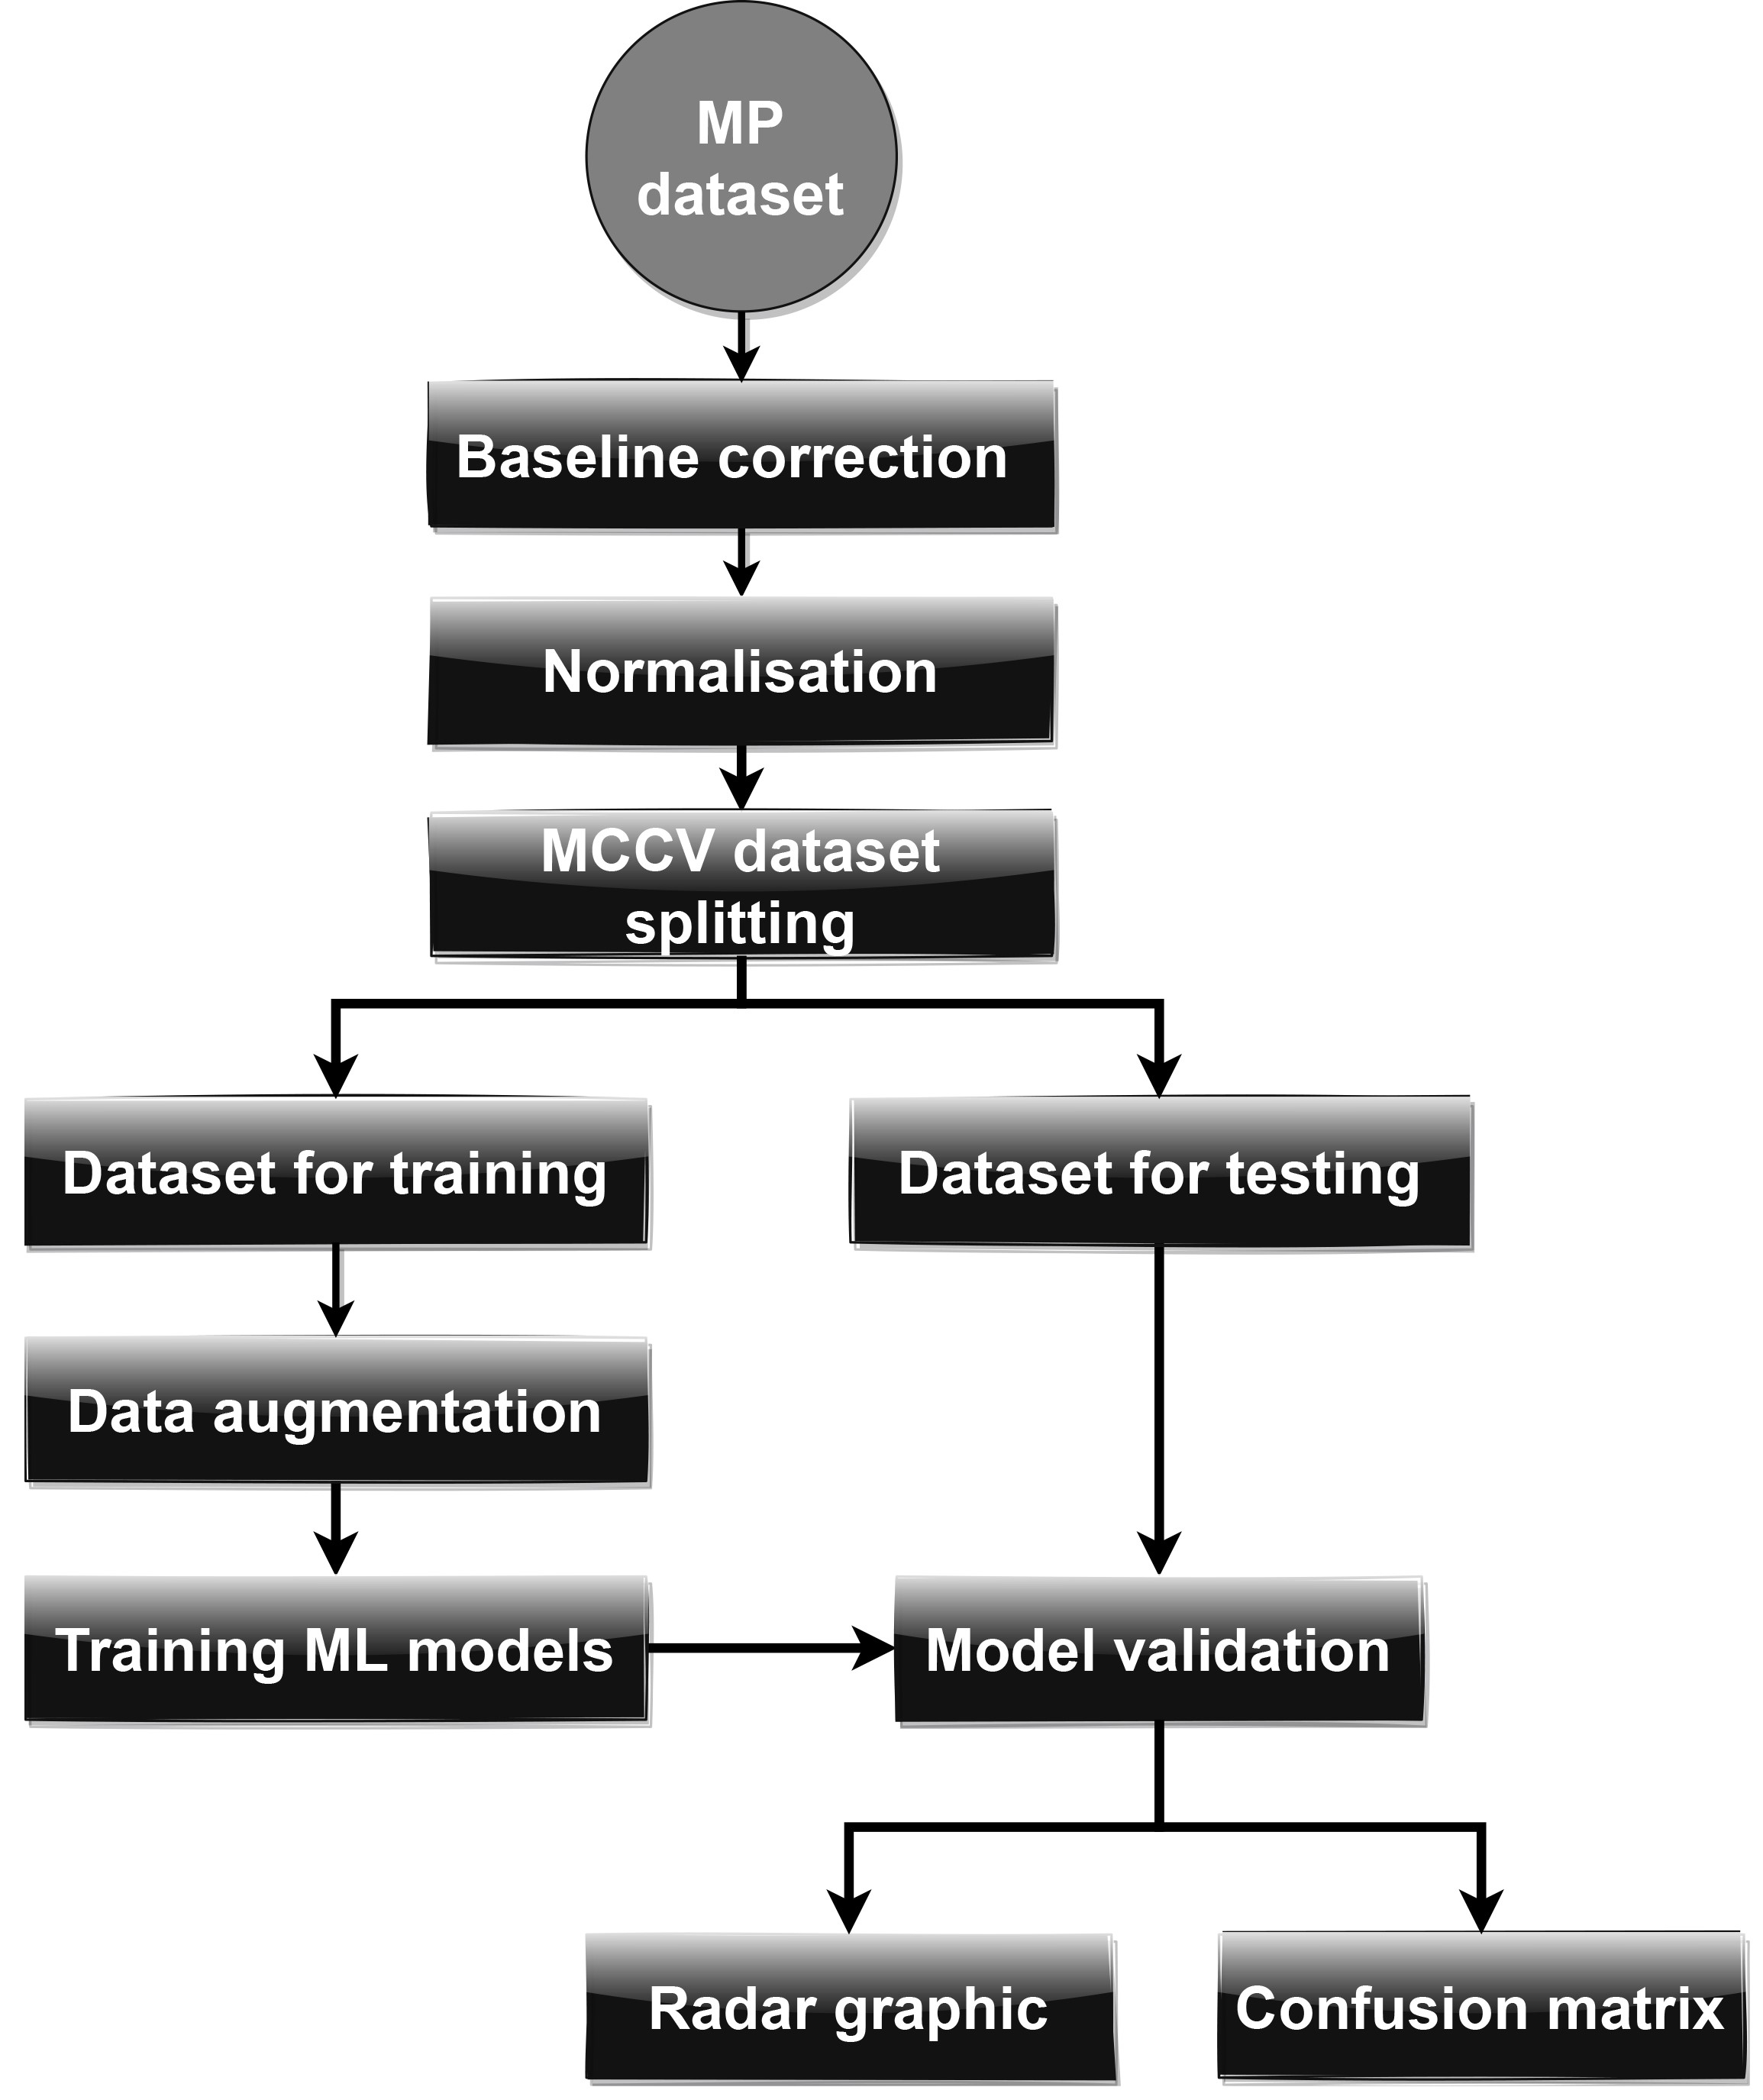
Figure 2 The strategy for comparison data augmentation for ML based method
The vibrational spectrum of MPs commonly consists of MP spectrums, baseline effects and noises. The baseline effects and noises will cause the data to be abnormal and consequently affect the ML model training performance. Hence, pre-processing methods are critical to reduce the error rates for ML approaches. The data pre-processing mainly includes two steps based on the previous work, i.e., baseline correction and normalisation (Renner et al., 2019) (Yan et al., 2022).
Baseline correction is to solve the drifting and sloping issues in the spectral data (Liland, 2015) (Liu et al., 2017). The baseline effects are derived from non-uniform optical properties, non-planar geometry of the samples (Renner et al., 2019) and features overlapped by the background (Peng et al., 2010). This work adopts the adaptive iteratively reweighted penalized least squares (airPLS) (Zhang et al., 2010) to correct the baseline effects. This method is a widely adopted algorithm in spectral baseline correction for retaining the adequate information. The example of baseline correction methods is depicted in Figure A.3
Normalisation is the process to limit the data in a standard range for training ML models. Based on the previous work (Yan et al., 2022), the Normalisation method with parameter max performs the best in classifying MP FTIR dataset. Hence, this work adopts this method for data normalisation. As depicted in Figure A.1, the FTIR spectral data have all been pre-processed through baseline correction and normalisation.
To achieve representative results, this work adopts Monte Carlo Cross-Validation (MCCV) (Xu and Liang, 2001) to divide the dataset randomly into a training set and a testing set in the proportion of 70% and 30%. MCCV randomly selects the data samples (without repetition) to form the training set and testing set. The process repeats multiple times, generating (randomly) new training and testing sets in each iteration. Afterwards, it calculates the average values of each iteration. This work utilises 20 different random seeds to sperate the dataset and in each iteration, augment the training set to train the ML models.
To systematically analyse the ML classification results, this work adopts the 2 comparison methods utilised in the previous work (Yan et al., 2022), i.e., radar chart and confusion matrix, which can depict the algorithm performance from macroscopic and microscopic perspectives respectively. The radar chart calculates the average value of kappa score, f1, accuracy, precision, recall for all the MP classes (Yan et al., 2022). The average scores can show the overall performance of different augmentation methods for the ML methods. Confusion matrix (CM) (Shah et al., 2020) (Luque et al., 2019) is utilised for depicting the relationship between the actual MPs and the predicted MPs. CM can display prediction results for each MP class from microscopic aspects. For each row of a CM, the diagonal value is the recall score, and the other values of this row are the misclassified results. Based on these metrics, it can evaluate the results of an ML model from both macro and micro perspectives and then display the effects of different data augmentation method on the ML classification methods.
  - Methods for programming
In this work, the airPLS algorithm is implemented by the Numpy library of Python. The normalisation algorithm, the MCCV data splitting algorithm, SVM, KNN, MLP and metrics of ML are implemented with the Scikit-learning (Sklearn) library of Python (Pedregosa et al., 2011) (Buitinck et al., 2013). To adjust the hyperparameters of the ML methods, the GridSearchCV function of Sklearn is utilised to obtain the best results.
- ACKNOWLEDGMENTS
This publication has emanated from research conducted with the financial support of the Technological University of the Shannon under President Doctoral Scholarship 2020, and Science Foundation Ireland (SFI) under Grant Number SFI 16/RC/3918, co-funded by the European Regional Development Fund.
Appendix A. Supplementary data
Appendix A Supplementary figures and tables.

REFERENCES
Back, H. de M., Vargas Junior, E.C., Alarcon, O.E., Pottmaier, D., 2022. Training and evaluating machine learning algorithms for ocean microplastics classification through vibrational spectroscopy. Chemosphere 287, 131903. https://doi.org/10.1016/j.chemosphere.2021.131903
Bjerrum, E.J., Glahder, M., Skov, T., 2017. Data Augmentation of Spectral Data for Convolutional Neural Network (CNN) Based Deep Chemometrics 1–10.
Blazhko, U., Shapaval, V., Kovalev, V., Kohler, A., 2021. Comparison of augmentation and pre-processing for deep learning and chemometric classification of infrared spectra. Chemom. Intell. Lab. Syst. 215, 104367. https://doi.org/10.1016/j.chemolab.2021.104367
Bostan, N., Ilyas, N., Akhtar, N., Mehmood, S., Saman, R.U., Sayyed, R.Z., Shatid, A.A., Alfaifi, M.Y., Elbehairi, S.E.I., Pandiaraj, S., 2023. Toxicity assessment of microplastic (MPs); a threat to the ecosystem. Environ. Res. 234, 116523. https://doi.org/10.1016/j.envres.2023.116523
Brandt, J., Mattsson, K., Hassellöv, M., 2021. Deep Learning for Reconstructing Low-Quality FTIR and Raman Spectra─A Case Study in Microplastic Analyses. Anal. Chem. 93, 16360–16368. https://doi.org/10.1021/acs.analchem.1c02618
Buitinck, L., Louppe, G., Blondel, M., Pedregosa, F., Mueller, A., Grisel, O., Niculae, V., Prettenhofer, P., Gramfort, A., Grobler, J., Layton, R., Vanderplas, J., Joly, A., Holt, B., Varoquaux, G., 2013. API design for machine learning software: experiences from the scikit-learn project 1–15.
Cole, M., Lindeque, P., Halsband, C., Galloway, T.S., 2011. Microplastics as contaminants in the marine environment: A review. Mar. Pollut. Bull. 62, 2588–2597. https://doi.org/10.1016/j.marpolbul.2011.09.025
Cortes, C., Vapnik, V., 1995. Support-vector networks. Mach. Learn. 20, 273–297.
De Frond, H., Rubinovitz, R., Rochman, C.M., 2021. μATR-FTIR Spectral Libraries of Plastic Particles (FLOPP and FLOPP-e) for the Analysis of Microplastics. Anal. Chem. 93, 15878–15885.
De Maesschalck, R., Jouan-Rimbaud, D., Massart, D.L., 2000. The mahalanobis distance. Chemom. Intell. Lab. Syst. 50, 1–18.
Gardner, M.W., Dorling, S.R., 1998. Artificial neural networks (the multilayer perceptron) - a review of applications in the atmospheric sciences. Atmos. Environ. 32, 2627–2636. https://doi.org/10.1016/S1352-2310(97)00447-0
Halstead, J.E., Smith, J.A., Carter, E.A., Lay, P.A., Johnston, E.L., 2018a. Assessment tools for microplastics and natural fibres ingested by fish in an urbanised estuary. Environ. Pollut. 234, 552–561. https://doi.org/10.1016/j.envpol.2017.11.085
Halstead, J.E., Smith, J.A., Carter, E.A., Lay, P.A., Johnston, E.L., 2018b. Assessment tools for microplastics and natural fibres ingested by fish in an urbanised estuary. Environ. Pollut. 234, 552–561. https://doi.org/10.1016/j.envpol.2017.11.085
Hufnagl, B., Steiner, D., Renner, E., Löder, M.G.J., Laforsch, C., Lohninger, H., 2019. A methodology for the fast identification and monitoring of microplastics in environmental samples using random decision forest classifiers. Anal. Methods 11, 2277–2285. https://doi.org/10.1039/c9ay00252a
Jung, M.R., Balazs, G.H., Work, T.M., Jones, T.T., Orski, S. V., Rodriguez C, V., Beers, K.L., Brignac, K.C., Hyrenbach, K.D., Jensen, B.A., Lynch, J.M., 2018a. Polymer Identification of Plastic Debris Ingested by Pelagic-Phase Sea Turtles in the Central Pacific. Environ. Sci. Technol. 52, 11535–11544. https://doi.org/10.1021/acs.est.8b03118
Jung, M.R., Balazs, G.H., Work, T.M., Jones, T.T., Orski, S. V., Rodriguez C, V., Beers, K.L., Brignac, K.C., Hyrenbach, K.D., Jensen, B.A., Lynch, J.M., 2018b. Polymer Identification of Plastic Debris Ingested by Pelagic-Phase Sea Turtles in the Central Pacific. Environ. Sci. Technol. 52, 11535–11544. https://doi.org/10.1021/acs.est.8b03118
Kedzierski, M., Falcou-Préfol, M., Kerros, M.E., Henry, M., Pedrotti, M.L., Bruzaud, S., 2019. A machine learning algorithm for high throughput identification of FTIR spectra: Application on microplastics collected in the Mediterranean Sea. Chemosphere 234, 242–251. https://doi.org/10.1016/j.chemosphere.2019.05.113
Kohler, A., Kirschner, C., Oust, A., Martens, H., 2005. Extended multiplicative signal correction as a tool for separation and characterization of physical and chemical information in fourier transform infrared microscopy images of cryo-sections of beef loin. Appl. Spectrosc. 59, 707–716. https://doi.org/10.1366/0003702054280649
Liland, K.H., 2015. 4S Peak Filling - Baseline estimation by iterative mean suppression. MethodsX 2, 135–140. https://doi.org/10.1016/j.mex.2015.02.009
Liu, J., Osadchy, M., Ashton, L., Foster, M., Solomon, C.J., Gibson, S.J., 2017. Deep convolutional neural networks for Raman spectrum recognition: A unified solution. Analyst 142, 4067–4074. https://doi.org/10.1039/c7an01371j
Luque, A., Carrasco, A., Martín, A., de las Heras, A., 2019. The impact of class imbalance in classification performance metrics based on the binary confusion matrix. Pattern Recognit. 91, 216–231. https://doi.org/10.1016/j.patcog.2019.02.023
McKinley, S., Levine, M., 1998. Cubic spline interpolation. Coll. Redwoods 45, 1049–1060.
Mecozzi, M., Pietroletti, M., Monakhova, Y.B., 2016. FTIR spectroscopy supported by statistical techniques for the structural characterization of plastic debris in the marine environment: Application to monitoring studies. Mar. Pollut. Bull. 106, 155–161. https://doi.org/10.1016/j.marpolbul.2016.03.012
Michel, A.P.M., Morrison, A.E., Preston, V.L., Marx, C.T., Colson, B.C., White, H.K., 2020. Rapid Identification of Marine Plastic Debris via Spectroscopic Techniques and Machine Learning Classifiers. Environ. Sci. Technol. 54, 10630–10637. https://doi.org/10.1021/acs.est.0c02099
Neto, J.G.B., Rodrigues, F.L., Ortega, I., Rodrigues, L. dos S., Lacerda, A.L. d. F., Coletto, J.L., Kessler, F., Cardoso, L.G., Madureira, L., Proietti, M.C., 2020. Ingestion of plastic debris by commercially important marine fish in southeast-south Brazil. Environ. Pollut. 267. https://doi.org/10.1016/j.envpol.2020.115508
Pedregosa, F., Varoquaux, G., Gramfort, A., Michel, V., Thirion, B., Grisel, O., Blondel, M., Prettenhofer, P., Weiss, R., Dubourg, V., 2011. Scikit-learn: Machine learning in Python. J. Mach. Learn. Res. 12, 2825–2830.
Peng, J., Peng, S., Jiang, A., Wei, J., Li, C., Tan, J., 2010. Asymmetric least squares for multiple spectra baseline correction. Anal. Chim. Acta 683, 63–68. https://doi.org/10.1016/j.aca.2010.08.033
Peterson, L.E., 2009. K-nearest neighbor. Scholarpedia 4, 1883.
Primpke, S., Wirth, M., Lorenz, C., Gerdts, G., 2018. Reference database design for the automated analysis of microplastic samples based on Fourier transform infrared (FTIR) spectroscopy. Anal. Bioanal. Chem. 410, 5131–5141. https://doi.org/10.1007/s00216-018-1156-x
Renner, G., Nellessen, A., Schwiers, A., Wenzel, M., Schmidt, T.C., Schram, J., 2019. Data preprocessing & evaluation used in the microplastics identification process: A critical review & practical guide. TrAC - Trends Anal. Chem. 111, 229–238. https://doi.org/10.1016/j.trac.2018.12.004
Renner, G., Schmidt, T.C., Schram, J., 2018. Analytical methodologies for monitoring micro(nano)plastics: Which are fit for purpose? Curr. Opin. Environ. Sci. Heal. https://doi.org/10.1016/j.coesh.2017.11.001
Shah, K., Patel, H., Sanghvi, D., Shah, M., 2020. A Comparative Analysis of Logistic Regression, Random Forest and KNN Models for the Text Classification. Augment. Hum. Res. 5. https://doi.org/10.1007/s41133-020-00032-0
Smith, M.J., Holmes-Smith, A.S., Lennard, F., 2019. Development of non-destructive methodology using ATR-FTIR with PCA to differentiate between historical Pacific barkcloth. J. Cult. Herit. 39, 32–41. https://doi.org/10.1016/j.culher.2019.03.006
Snell, J., Swersky, K., Zemel, R., 2017. Prototypical networks for few-shot learning. Adv. Neural Inf. Process. Syst. 30.
Villegas-Camacho, O., Alejo-Eleuterio, R., Francisco-Valencia, I., Granda-Gutiérrez, E., Martínez-Gallegos, S., Illescas, J., 2024. FTIR-Plastics: A Fourier Transform Infrared Spectroscopy dataset for the six most prevalent industrial plastic polymers. Data Br. 55, 110612. https://doi.org/10.1016/j.dib.2024.110612
Xu, Q.S., Liang, Y.Z., 2001. Monte Carlo cross validation. Chemom. Intell. Lab. Syst. 56, 1–11. https://doi.org/10.1016/S0169-7439(00)00122-2
Yan, X., Cao, Z., Murphy, A., Qiao, Y., 2022. An ensemble machine learning method for microplastics identification with FTIR spectrum. J. Environ. Chem. Eng. 10, 108130. https://doi.org/https://doi.org/10.1016/j.jece.2022.108130
Yan, X., Cao, Z., Murphy, A., Ye, Y., Wang, X., Qiao, Y., 2023. FRDA: Fingerprint Region based Data Augmentation using explainable AI for FTIR based microplastics classification. Sci. Total Environ. 896, 165340. https://doi.org/https://doi.org/10.1016/j.scitotenv.2023.165340
Zhang, Z.M., Chen, S., Liang, Y.Z., 2010. Baseline correction using adaptive iteratively reweighted penalized least squares. Analyst 135, 1138–1146. https://doi.org/10.1039/b922045c

